[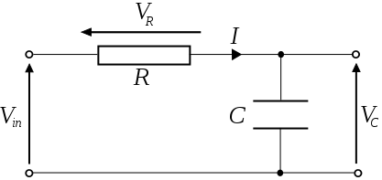](https://www.google.co.id/url?sa=i&url=https%3A%2F%2Fcommons.wikimedia.org%2Fwiki%2FFile%3ASeries-RC.svg&psig=AOvVaw22F2U2Yic-Teb1WyQCE_Jz&ust=1581596730985000&source=images&cd=vfe&ved=0CAIQjRxqFwoTCLjF9pSBzOcCFQAAAAAdAAAAABAb)

* Arus pada rangkaian
$$I=C\frac{dV_{C}}{dt}$$

* KVL

$$-V_{in}+V_{R}+V_{C}=0$$

$$-V_{in}+IR+V_{C}=0$$

$$-V_{in}+RC\frac{dV_{C}}{dt}+V_{C}=0$$

(gunakan pendekatan $\frac{dV_{C}}{dt}≈\frac{∆V_{C}}{∆t}={\frac{V_{C}(t)-V_{C}(t-∆t)}{∆t}}$)

$$-V_{in}+RC\frac{V_{C}\left(t\right)-V_{C}\left(t-∆t\right)}{∆t}+V_{C}(t)=0$$

$$-V_{in}∆t+RC\left(V_{C}\left(t\right)-V_{C}\left(t-∆t\right)\right)+V_{C}\left(t\right)∆t=0$$

$$V_{C}\left(t\right)=\frac{V_{C}\left(t-∆t\right)+\frac{V_{in}∆t}{RC}}{1+\frac{∆t}{RC}}=\frac{V_{C}\left(t-∆t\right)+b∆t}{1+c∆t}$$